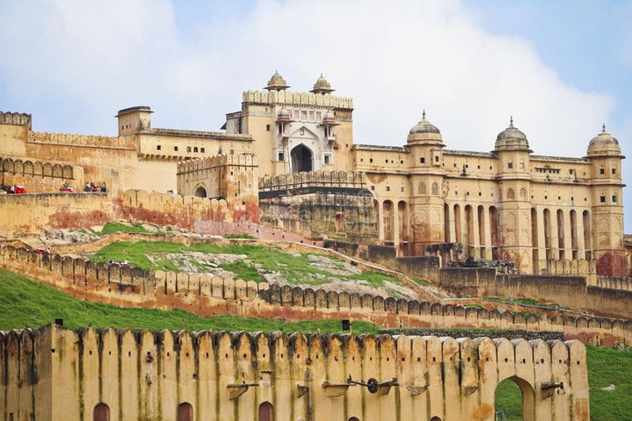
GOLDEN TRIANGLE WITH RANTHAMBORE
Circuit: Delhi – Ayodhya – Varanasi – Delhi
ITINERARY PUBBLICATO:
DAY 01: | DELHI – AYODHYA (VANDE BHARAT EXPRESS – 06:10HRS / 14:30HRS)
Morning board train for Ayodhya. Meeting and assistance upon arrival and transfer to hotel in Ayodhya. Rest of the day at Leisure and Evening enjoy local market.

Overnight stay at hotel in Ayodhya

DAY 02: | 14 SEP’26 | DELHI
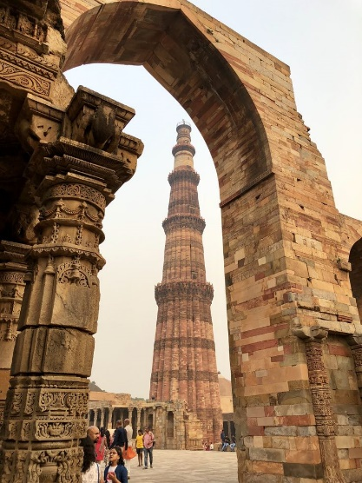
Morning after breakfast proceed for sightseeing tour of Delhi visiting New Delhi: Built in a typically British colonial style with tree-lined avenues and colonial bungalows. See the Laxminarayan Temple, a modern Hindu temple, and India Gate, the 42 m high War Memorial Arch. Drive past the Parliament House, the Secretariat buildings and the Vice Regal Palace, now the official residence of the President of India. You will also visit Qutab Minar – what was intended to be the most glorious tower of victory in the world and was to be the prototype of all minars in India. Then, go down to Old Delhi to visit the 17th century Jama Masjid, the largest mosque in India. See Chandni Chowk, the shopping center of old Delhi and drive past the Red Fort for a photo stop. Visit Raj Ghat where Mahatma Gandhi was cremated.

Overnight stay at hotel in Delhi

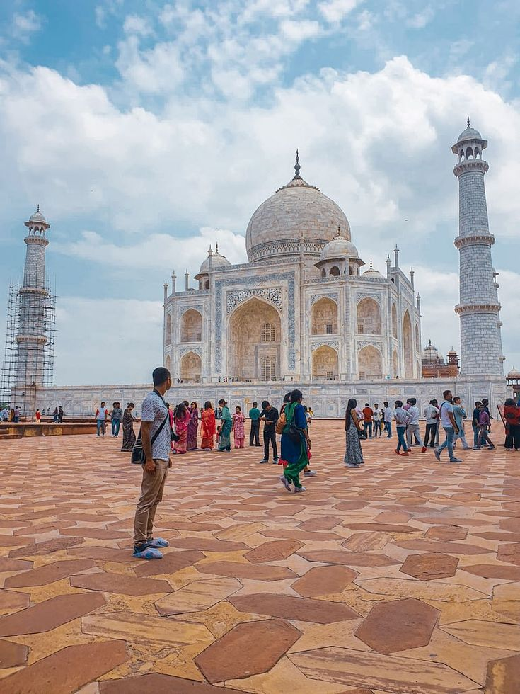
DAY 03: | 15 SEP’26| DELHI – AGRA (232Kms, 04Hrs)
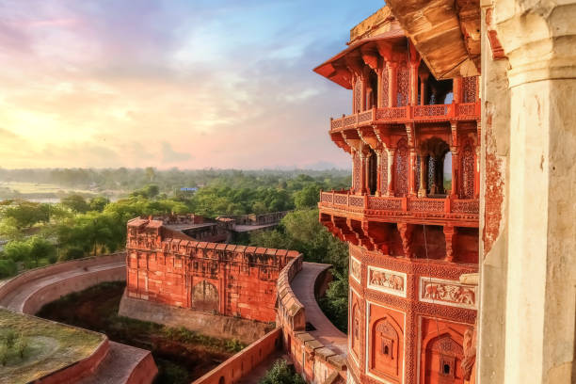
Morning after breakfast drive to Agra. Upon arrival check in at hotel in Agra. Afternoon proceed for sightseeing tour of Agra visiting Taj Mahal: Shahjahan, who was a passionate builder, now decided to erect a memorial marble that the world would never forget. The site was also chosen because it was located on a bend in the river, and so could be seen from Shahjahan's personal palace in Agra Fort, further upstream. The construction of the Taj Mahal started in 1631. It took 20,000 artisans 22 years to complete this poignant mauseoleum that blends subtlety with grandeur, and a massive overall design with immaculately intricate execution.

Agra Fort: The construction of the Agra Fort was begun by Emperor Akbar in 1565. Its massive walls stretch for 2½ km and are surrounded by a moat over 10 metres wide. The fort is really a city within a city, which embraces the Moti Masjid, the Diwan-i-Am or the Hall of Public Audiences, the Diwan-i-Khas or the Hall of Private Audiences, the Octagonal Tower, Jehangir’s Palace and many more monuments.

Overnight stay at hotel in Agra.

DAY 04: | 16 SEP’26| AGRA – BHARATPUR (57Kms, 01Hrs)
RANTHAMBORE (JAN SHATABDI EXPRESS: 14:52Hrs / 17:13Hrs)
Morning after breakfast on time transfer to Bharatpur railway station to board train for Sawai Madhopur. Meeting and assistance upon arrival at Swai Madhopur station and transfer to hotel. Upon arrivla check in at hotel.

Dinner & Overnight stay at hotel in Swai Madhopur (Ranthambore).
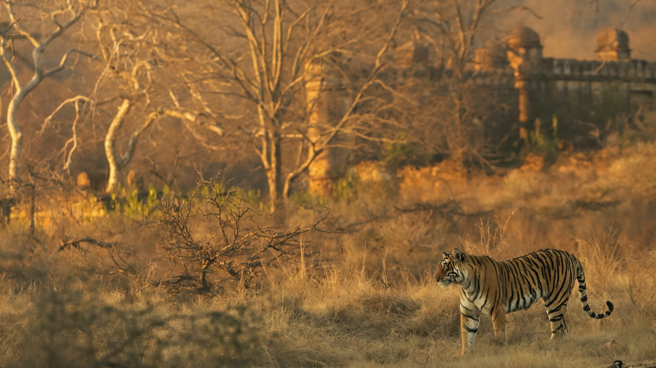
DAY 05: | 17 SEP’26| SAWAI MADHOPUR (RANTHAMBORE)
Morning and afternoon enjoy jungle safari at Ranthambore national park. The park is one of the finest tiger reserves in the country where more visitors spending a couple of nights are likely to spot one of these majestic animals. Once, private tiger reserve of the Maharaja of Jaipur, in 1972 the sanctuary came under the Project Tiger scheme. It covers 410 sq km and runs from the easternmost spur of the Aravalis to the Vindhya Range. It has both the old for and the wildlife sanctuary, also known as Sawai Madhopur, after the town, which has some Jain temples with gilded paintings.

Apart from tiger you can see herds of Chital and Sambar deer and sounde4rs of wild boar, Nilgai antelope and chinkara gazelles. There are also sloth beer, a few leopards and crocodiles. Extensive bird life includes spur flown, jungle forwl, patridges, quails, crested serpent eagle, woodpeckers, flycatchers etc. There are also water birds like storks, ducks and geese at the lakes and waterholes.

Dinner & Overnight stay in Rathambore
DAY 06: | 18 SEP’26| RANTAMBORE – JAIPUR (176Kms, 03Hrs)
Morning after breakfast drive to Jaipur. Upon arrival check in at hotel in Jaipur.

Rest of the day free for relaxation . explore surrounding

overnight stay at hotel in Jaipur

DAY 07: | 19 SEP’26| JAIPUR
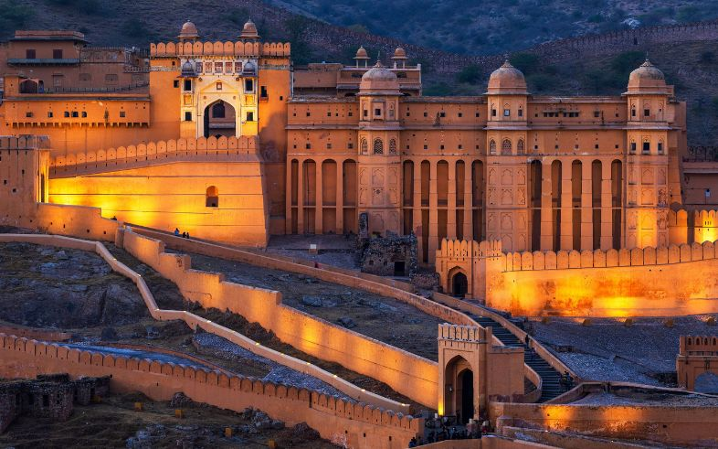
Morning after breakfast Visit the ancient Rajput capital of Amber, 11 km from the city. This fort-palace was begun by Raja Man Singh and used by the Rajputs as their stronghold until Sawai Jai Singh II moved to the newly created Jaipur. See the Diwan I Am or hall of public audience, Kali temple, Jai Mandir or hall of victory with its inlaid panels and mirror ceiling, and Sukh Niwas. The fort provides breathtaking views of the lake below.

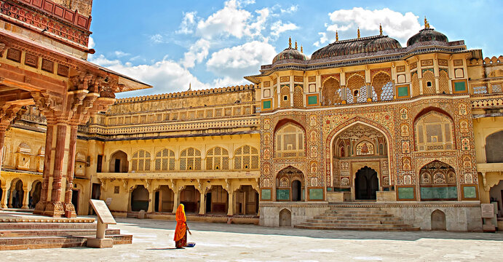
Afternoon proceed for sightseeing tour of Jaipur visiting the Maharaja’s City Palace and the Jantar Mantar Observatory. Jaipur’s walled City Palace (1732 AD) occupies one-seventh of the city’s area. See the Mubarak Mahal, museums of textiles and armoury etc, and the Diwan I Khas and Diwan I Am. Jantar Mantar, literally meaning “instruments for measuring the harmony of the heavens” is the oldest in India. Each instrument has a specific purpose and gives an accurate reading. Photo stop at Hawa Mahal (Palace of the Winds). Also, drive past the rose-pink residential and business areas of Jaipur

Overnight stay at hotel in Jaipur

DAY 08: | 20 SEP’26| JAIPUR – DELHI (298Kms, 4Hrs)
Morning after breakfast drive to Delhi. Upon arrival check in at hotel in Delhi.

Overnight stay in Delhi

DAY 09: | 21 SEP’26| DEPART DELHI
On time transfer to Delhi International Airport to board the flight for the onward destination.

COSTO DEL TOUR
CATEGORY | COST PER PERSON
Per person cost based on 05 star hotels | GBP
Supplement for Half Board (Dinner) starting fron Day 02 till Day 08 | GBP
COST BASED ON 5 STAR HOTELS | GBP

Cost based on 5 star hotels: Expected hotels
CiTY | HOTEL 5 STAR | DATE | ROOM | NIGHT
delhi | Leela Convention Hotel or similar | 13 – 15 Sep’26 | Deluxe Room | 02
Agra | Courtyard By Marriott or similar | 15 – 16 Sep’26 | Deluxe Room | 01
Ranthambore | Tigres or similar | 16 – 18 Sep’26 | Royal Luxury Suite | 02
Jaipur | Double Tree By Hilton or similar | 18 – 20 Sep’26 | King Guest Room | 02
Delhi | Prode Aerocity | 20 – 21 Sep’26 | Deluxe King Room | 01
TOTAL NUMBER OF NIGHTS |  |  |  | 08 Nights

Our prices include:

Price per person in a Triple room.

Bed and breakfast basis except in Ranthambore on Half Board (Breakfast + Dinner)

All arrival/departure transfer, sightseeing tour excursions by A/C Toyota Crysta as per program.

Entrance fees to Monuments

Services of English speaking loca guide as per program

Morning & afternoon jungle safari at Ranthambore National Park by shared jeep.

Jee ride at Amer Fort

Train tickets by Airconditioned Chair Car by Jan Shatabdi Express for Travel Bharatpur to Sawai Madhopur

2 night in Delhi with bed and breakfast.

1 night in Agra with bed and breakfast

2 nights in Rathambore on half board basis.

2 nights in Jaipur with bed and breakfast.

1 night in Delhi Aerocity on bed & breakfast.

Government tax.

Our prices do not include:

● Entry visa. Visas can be obtained online at: www.indianvisaonline.gov.in

● Tips for guides (at the client's discretion).

● Travel and cancellation insurance (optional).

● Beverages.
● Any services not mentioned as included, including personal extras such as telephone calls, laundry service, etc.

